Name : Youssef Kamel Ahmed Kamel

Group : 8

Section :48

B.N : 14

Topic : Artificial Intelligence

Brief : Artificial Intelligence Is Important And will be very Useful In The Future And will Be Used In Many Field And Its Engineers Comes From Mechatronics Engineering Department

ScreenShots :

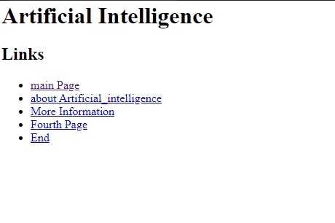

Source Code :

